Gas Laws T2W10

# Pressure

Pressure is a measure of force per unit area

For a *gas*, pressure is a measure of the average number of collisions per unit time

The SI unit for pressure is **Pascals (Pa)** 1 Pa = 1 N/m^2^

*Other units for pressure:*

### Kilopascals (kPa)

1 kPa = 1000 Pa

**Atmospheres (atm)** 1 atm = 101.3 kPa

### Millimetres of Mercury (mmHg)

1 mmHg = 133.3 Pa

1 kPa = 7.5 mmHg

# Ideal Gases

Used as a simpliﬁed model to predict the behaviour of gases.

## *Behaviour of real gases is complicated.*

The ideal gas assumptions are suitable for modelling gases at higher temperatures and lower pressures.

Model starts to fail at low temperatures and at high pressures.

*Ideal Gases - Assumptions:*

1. All gas molecules display the same behaviour. No diﬀerences arise from diﬀerent molecules / chemical nature (i.e. O2, H2, Cl2, and CO2 gas would all display the same behaviour).
2. Gas molecules do not interact with each other – intermolecular forces are negligible.
3. The volume of gas particles is negligible compared to the volume taken up by the gas.

# Kinetic Theory of Gases

1. **A gas consists of small particles (atoms or molecules) that move randomly with rapid velocities.** Gas molecules moving in all directions at high speeds cause a gas to ﬁll the entire volume of a container.
2. **Intermolecular forces between gas particles are negligible.** Gas particles move far apart and will expand to ﬁll a container of any size and shape.
3. **The actual volume occupied by gas molecules is very small.** Most of the volume of a gas is empty space, which allows gases to be compressed.
4. **The average kinetic energy of gas molecules is directly proportional to the temperature (in Kelvin).** Gas particles move faster as the temperature increases, hitting the walls of the container with more force and producing higher pressures.
5. **Gas particles move in straight paths until colliding with other gas particles or with the walls of the container to bounce oﬀ** *elastically* **in other directions.** An increase in either the frequency or force of collisions against the walls of the container causes an increase in the **gas pressure.**

# Ideal Gases - Conditions

### Standard Temperature and Pressure (STP)

STP = 273 K (0oC) and 100 kPa, 22.4 L/mol

### Standard Laboratory Conditions (SLC)

SLC = 298 K and 100 kPa, 24.8 L/mol

### Room Temperature and Pressure (RTP)

RTP = 298 K and 1 atm, 24.0 L/mol

# Boyle’s Law

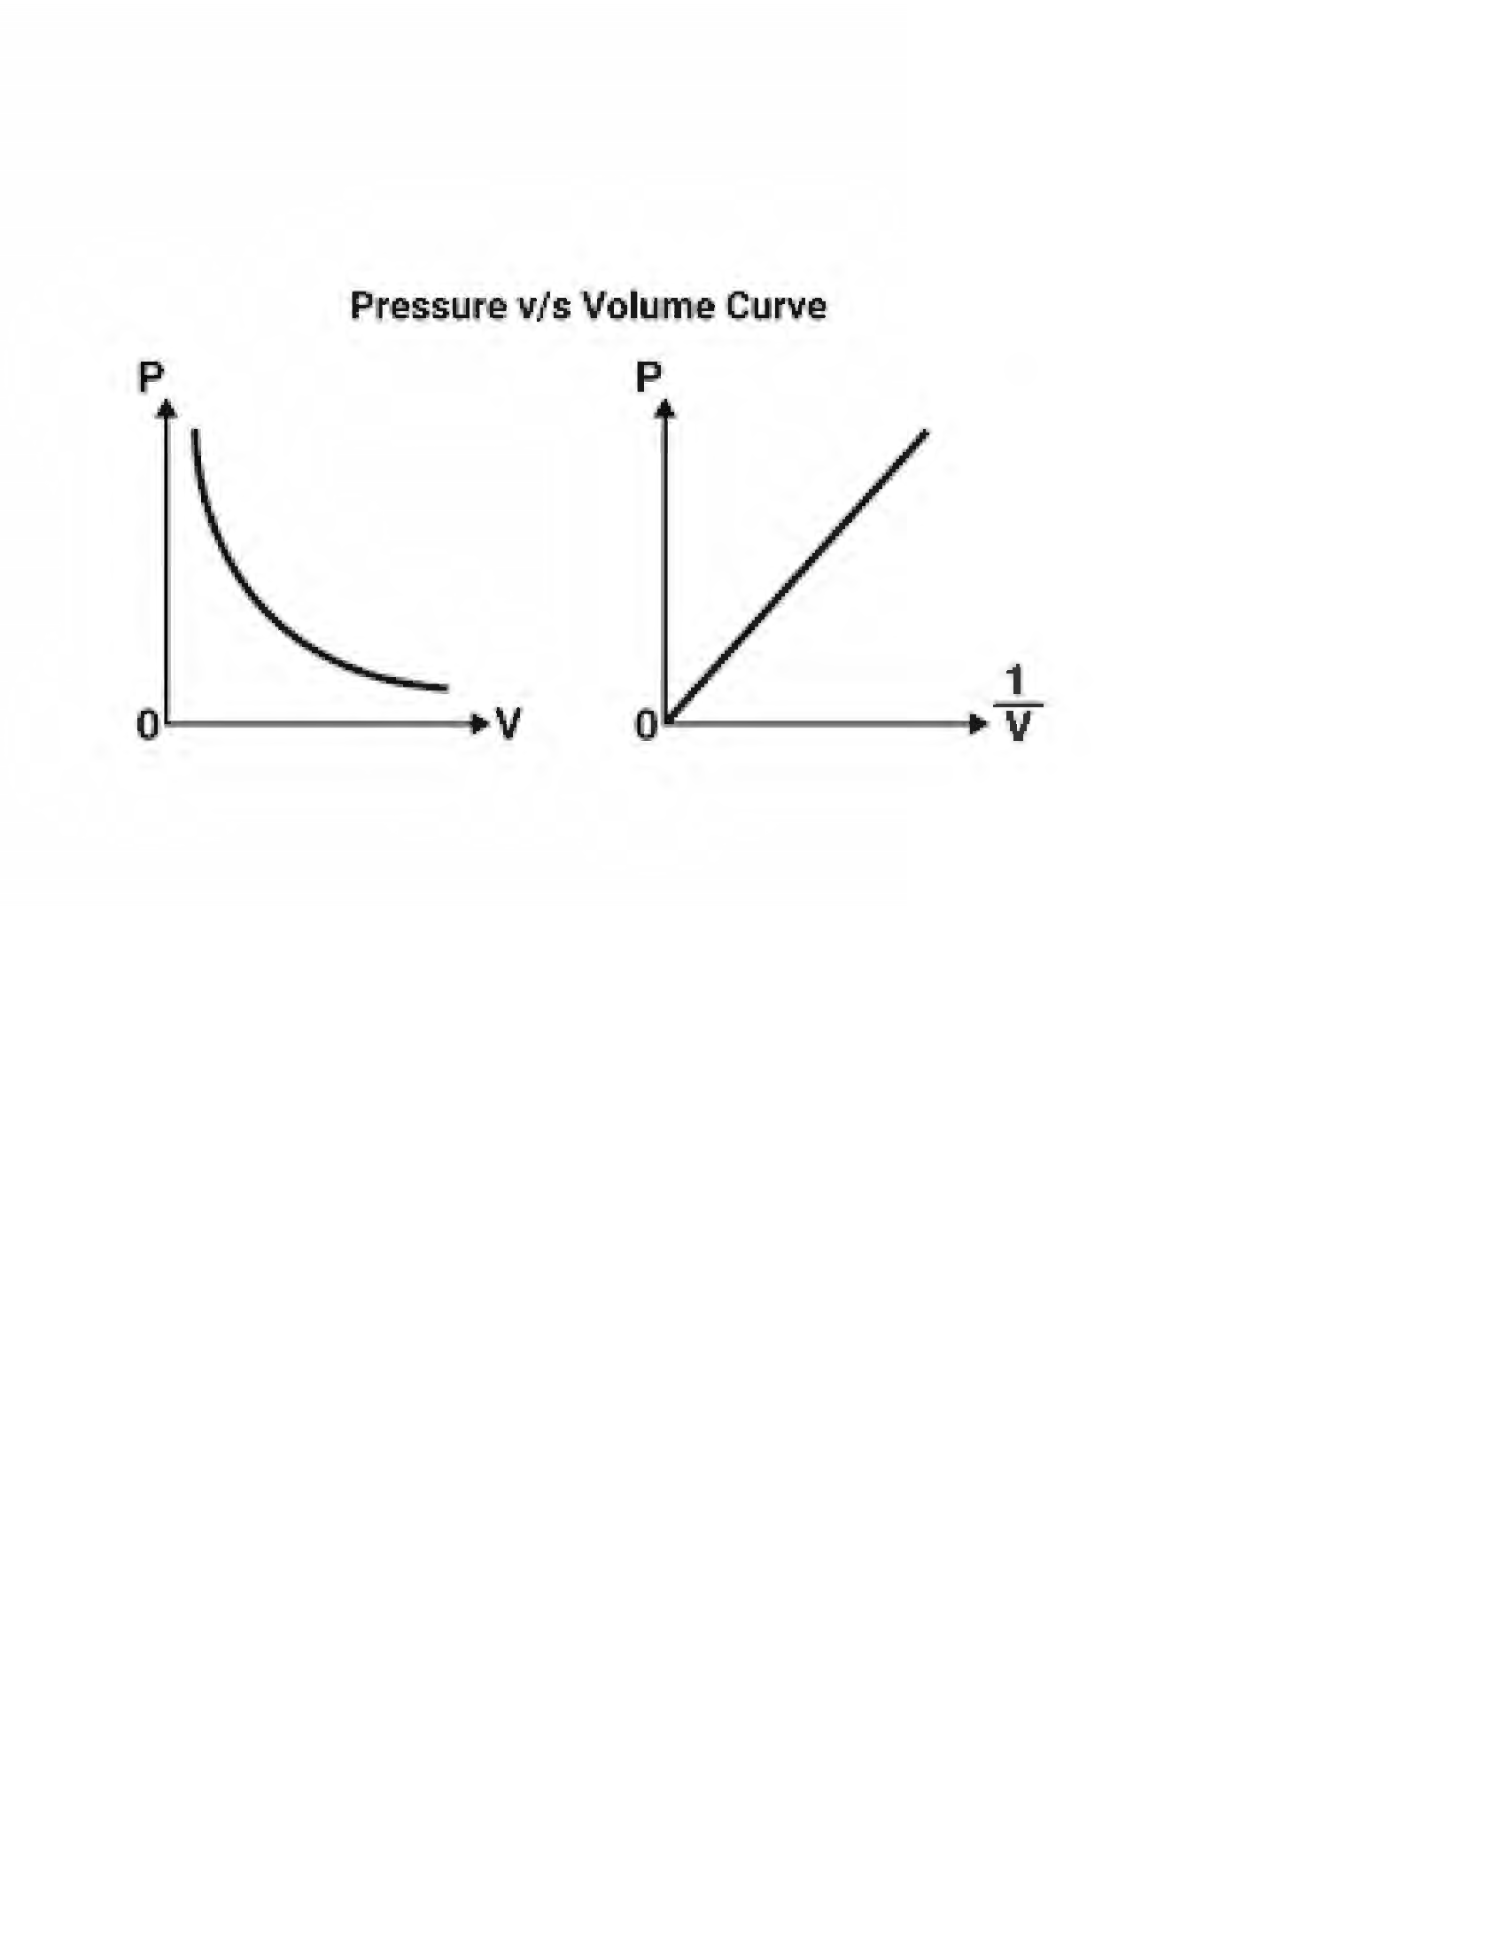Inverse relationship between volume and pressure. As volume increases, pressure decreases.

## *When temperature and moles are constant.*

V~1~P~1~ = V~2~P~2~

*Boyle’s Law Practice Questions:*

1. If a gas at 25.0 °C occupies 3.60 liters at a pressure of 1.00 atm, what will be its volume at a pressure of 2.50 atm?

1.44 L

1. A gas occupies 12.3 liters at a pressure of 40.0 mmHg. What is the volume when the pressure is increased to 60.0 mmHg?

8.2 L

1. A gas occupies 1.56 L at 1.00 atm. What will be the volume of this gas if the pressure is increased to 3.00 atm?

0.52 L

1. Two bulbs of diﬀerent volumes are separated by a valve. The valve between the

2.00 L bulb, in which the gas pressure is 1.00 atm, and the 3.00 L bulb, in which the gas pressure is 1.50 atm, is opened. What is the ﬁnal pressure in the two bulbs, the temperature being constant and the same in both bulbs?

1.3 atm

# Charles’ Law

Proportional relationship between temperature and volume. As temperature increases, volume also increases.

## *When pressure and moles are constant.*

V~1~/T~1~ = V~2~/T~2~

*Charles’ Law Practice Questions:*

1. Calculate the decrease in temperature (in Celsius) when 2.00 L at 21.0 °C is compressed to 1.00 L.

−126°C

1. A gas occupies 900.0 mL at a temperature of 27.0 °C. Calculate the volume if the temperature is increased to 132.0 °C.

1215 mL

1. At 210.0 °C, a gas has a volume of 8.00 L. Calculate the volume of this gas at

-23.0 °C.

1. An open "empty" 2 L plastic pop container, which has an actual inside volume of

2.05 L, is removed from a refrigerator at 5 °C and allowed to warm up to 21 °C. Calculate the volume of air that will leave the container as it warms to 21 °C?

# Avogadro’s Law

Proportional relationship between moles and volume. As number of moles increase, volume also increases.

## *When pressure and temperature are constant.*

V~1~/n~1~ = V~2~/n~2~

*Avogadro’s Law Practice Questions:*

1. 5.00 L of a gas is known to contain 0.965 mol. If the amount of gas is increased to 1.80 mol, calculate the new volume (at constant temperature and pressure).
2. A cylinder with a movable piston contains 2.00 g of helium (He) at 298 K. More helium was added to the cylinder and the volume was adjusted so that the gas pressure remained the same. Calculate the mass of helium that was added to the cylinder if the volume was changed from 2.00 L to 2.70 L at constant temperature. Give your answer in grams.
3. At a certain temperature and pressure, one mole of diatomic H2 gas occupies a volume of 20 L. What would be the volume of one mole of He atoms under those same conditions?

# Ideal Gas Law

PV = nRT

### Where:

P = Pressure (kPa) V = Volume (L)

n = number of moles (mol)

R = Ideal gas constant 8.314 J/K/mol T = Temperature (K)

*Ideal Gas Law - Alternative ‘R’ Constant:*

Important point is to make sure that your units are consistent.

You may also see the ideal gas constant R = 0.082 L atm / K / mol If you use this gas constant, you need:

P = Pressure (atm) V = Volume (L)

n = moles (mol)

R = 0.082 L .atm/K/mol T = temperature (K)

Practice Questions:

1. Derive Boyle’s Law from the Ideal Gas equation.
2. Derive Charles’ Law from the Ideal Gas equation.
3. Calculate the number of moles of CO2(g) in a 5.6 L sample of CO2 measured at STP.
4. At 150oC and 100 kPa, 1.00 L of a compound has a mass of 2.506 g. Calculate its molar mass.
5. Calculate the mass of Cl2 (g) that can be stored in a 10.0 L container at 1000 kPa and 30oC.
6. A balloon containing 2L of gas at STP is heated to SLC. Determine the new volume of the balloon.